**TUGAS LATIHAN JQUERY DI LARAVEL**

**Nama: Fakhri Alauddin Tarihoran**

**Nim: 0702233130**

**Sem/Prodi: V/Sistem Informasi**

1. **Screenshoot coding**

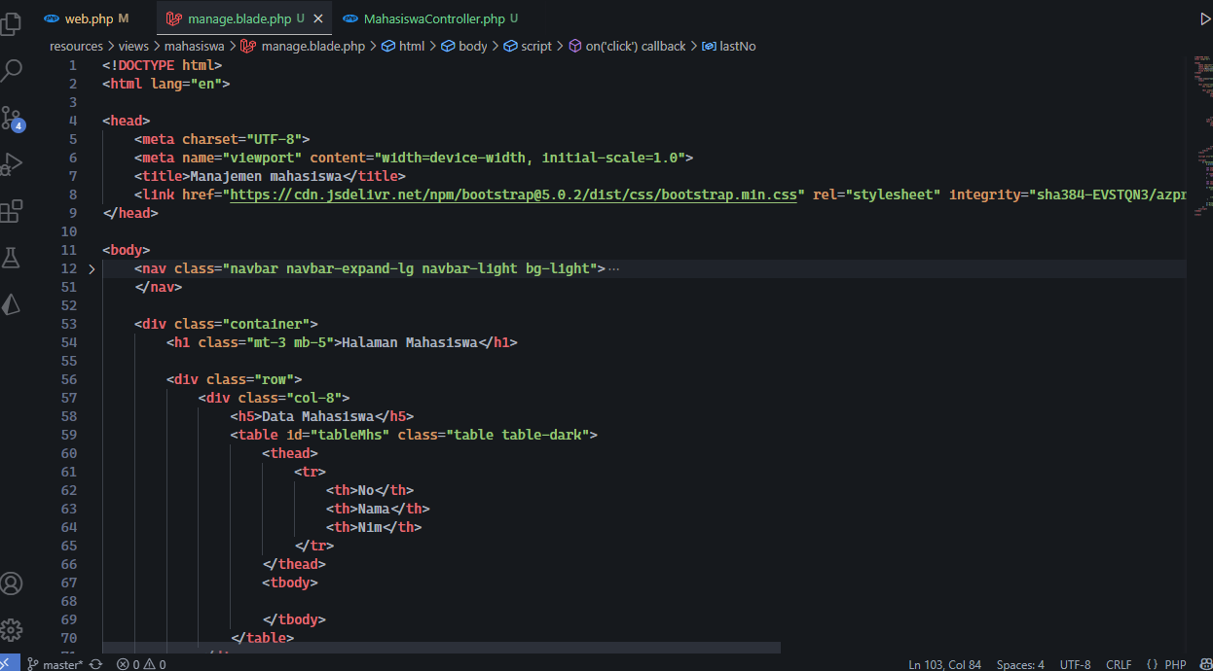

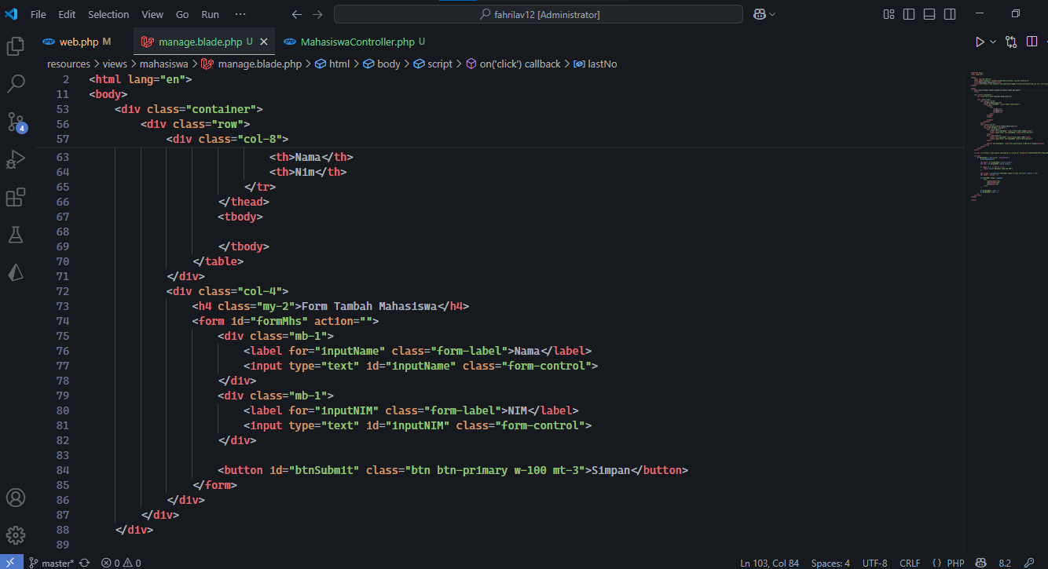

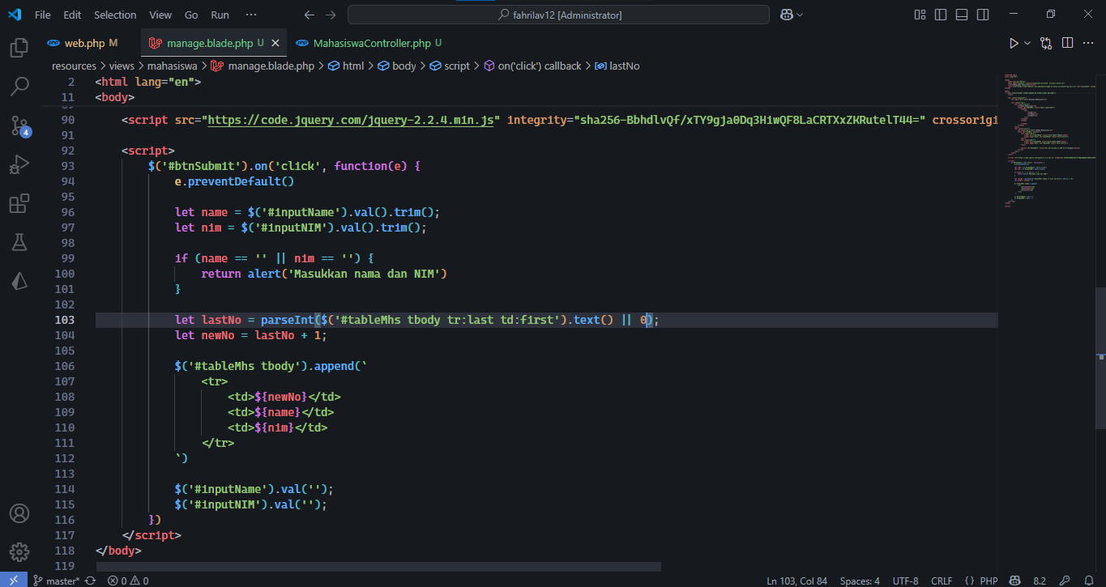

1. **Hasil**

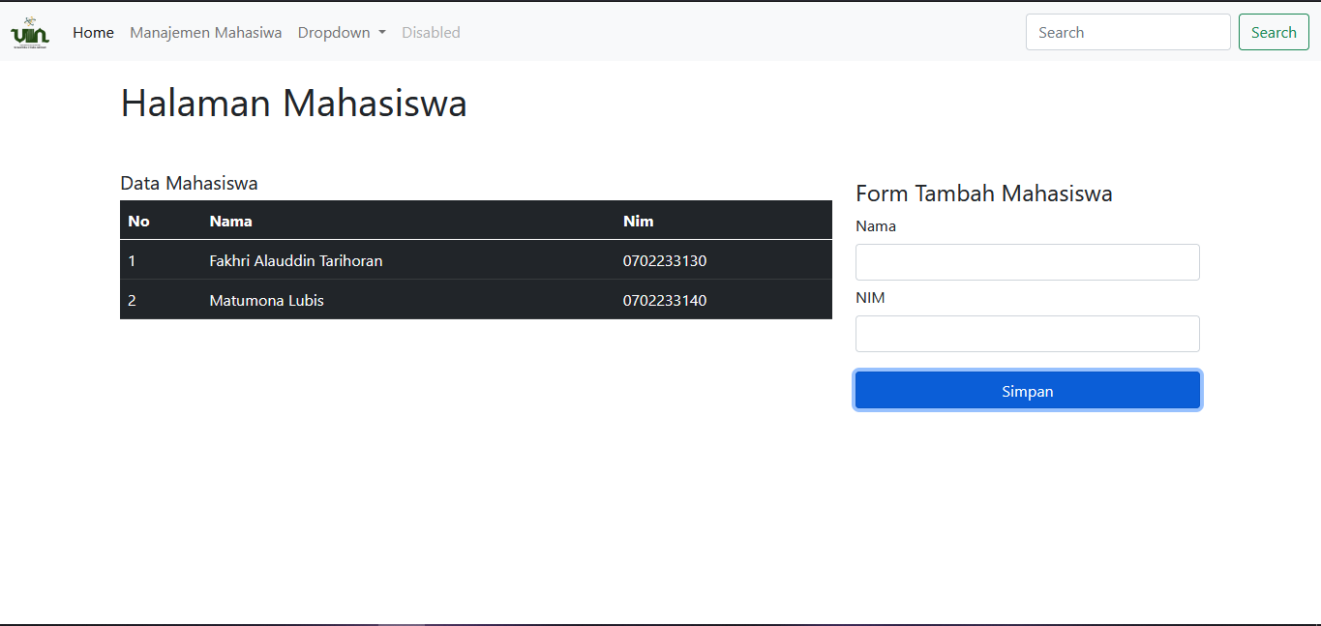

1. **Link Github**

**Link:** [**https://github.com/fahriTrh/fahrilav12**](https://github.com/fahriTrh/fahrilav12)

**Link Commit:** [**https://github.com/fahriTrh/fahrilav12/commit/49c55af9d44de3cc9b7020f9b813fbe5f3f77ceb**](https://github.com/fahriTrh/fahrilav12/commit/49c55af9d44de3cc9b7020f9b813fbe5f3f77ceb)